**Week-07**

**DLD LAB-07**

**K-map Standard SOP, Non-Standard SOP, Minimized SOP, Universal Gates**

**Objectives:**

* To understand concept of K-map standard SOP, Non-standard SOP, minimized SOP, Universal gate (NAND gate).
* To validate implementation of circuits using Circuit Maker 2000.

**Standard SOP Form (using K-map)**

* All product terms **use all variables** (either in normal or complemented form).
* It's like a complete and expanded form of the Boolean function.
* Each row of the truth table where **output = 1** becomes one product term.

**Example-01 (Standard SOP Form using K-map):**

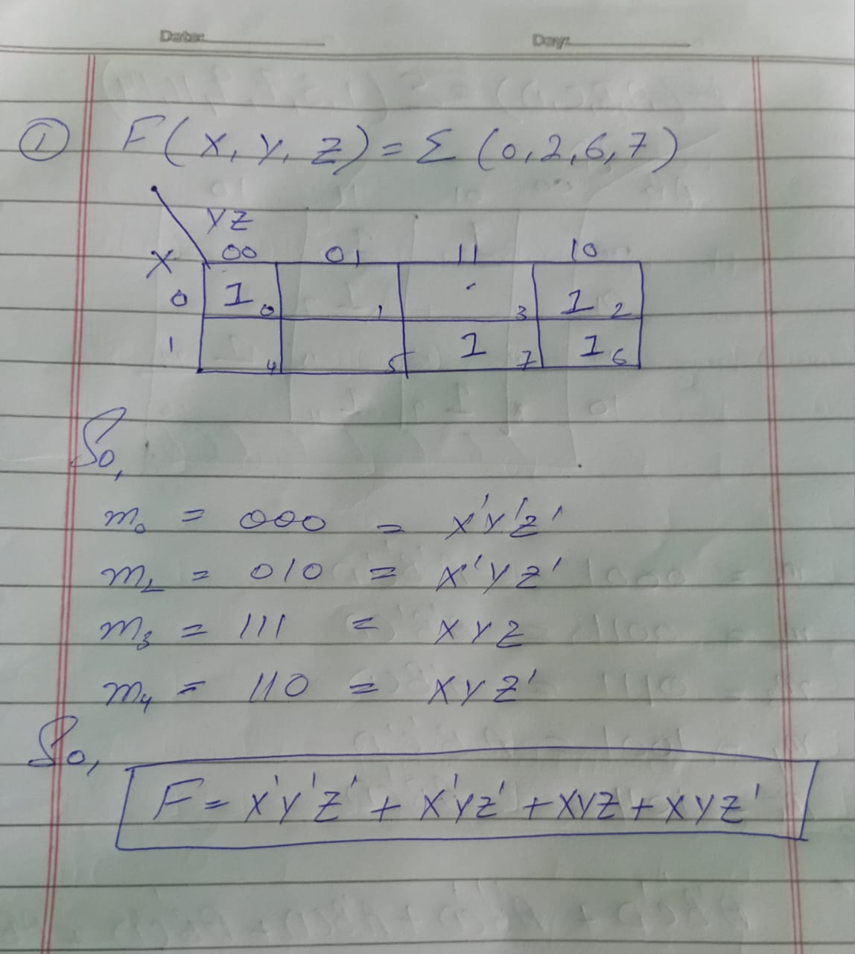

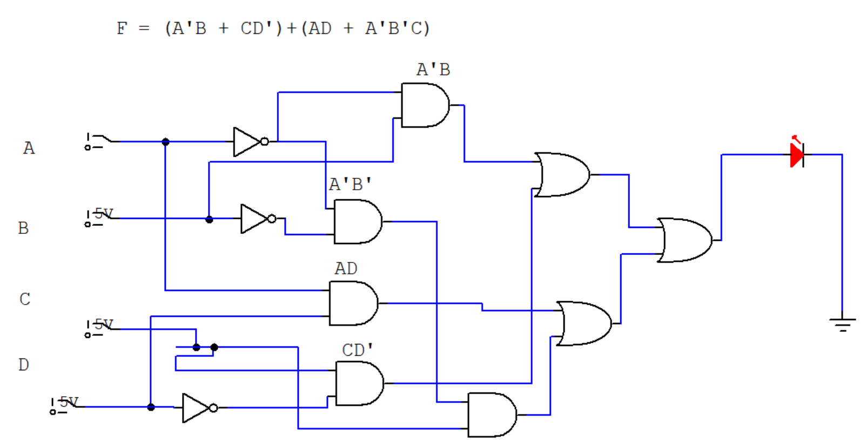

**Non-Standard SOP Form (using K-map)**

* This is the **simplified SOP** after grouping 1s in the K-map.
* The final terms **may not include all variables** (some get eliminated due to grouping).
* It’s the minimized Boolean expression.

If you perform **K-Map grouping**, then:

* 🔹 The result is **Non-Standard SOP** because the terms will **not include all variables**.
* 🔹 The result is also the **Minimized SOP**, because K-Map helps you find the **shortest and most simplified** Boolean expression.

**Example-02 (Non-Standard SOP):**

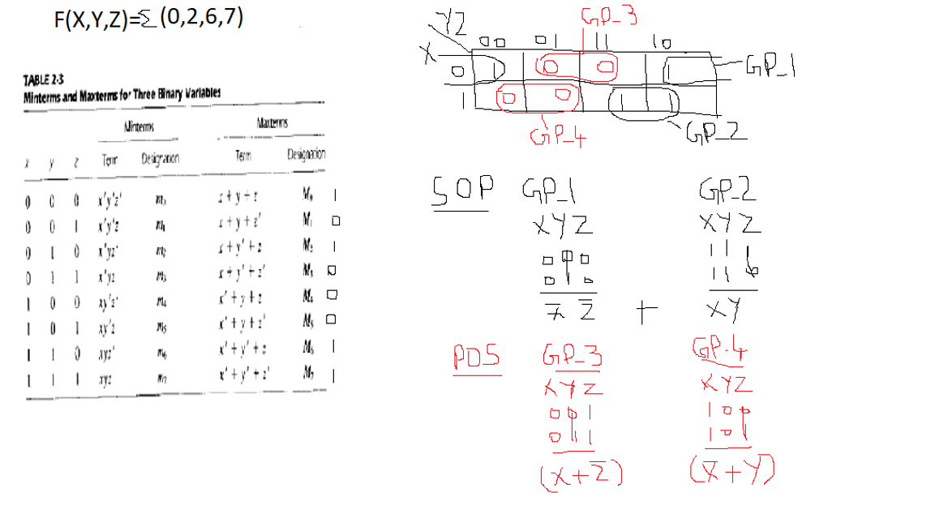

**Example-02 (Non-Standard SOP):**

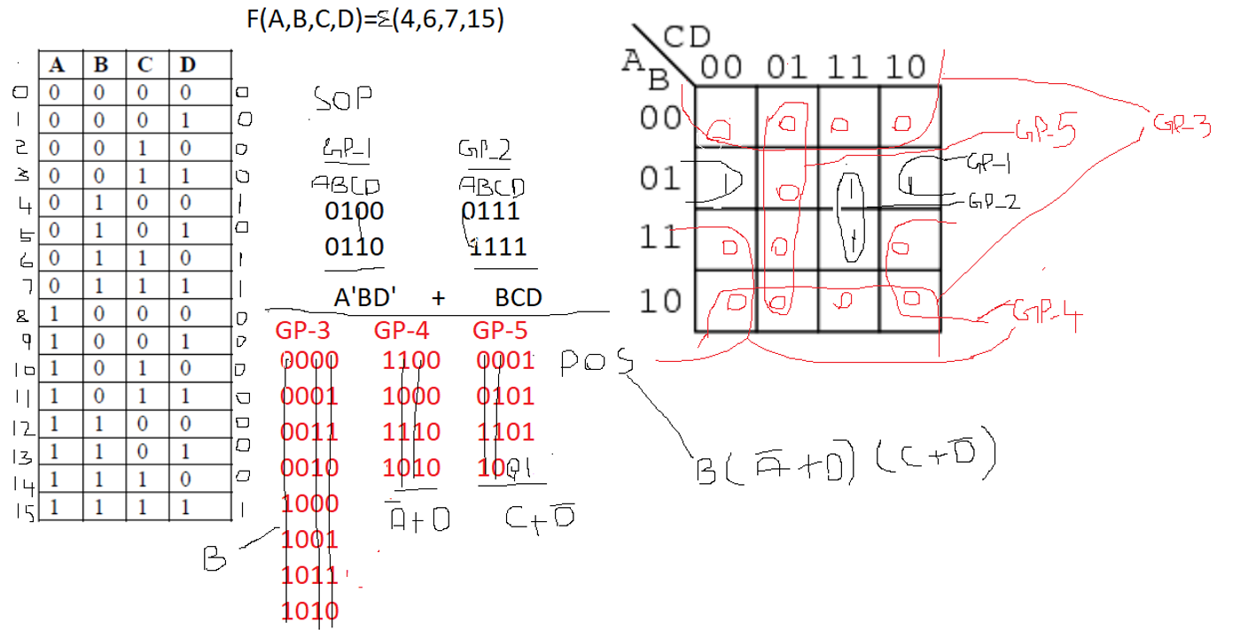

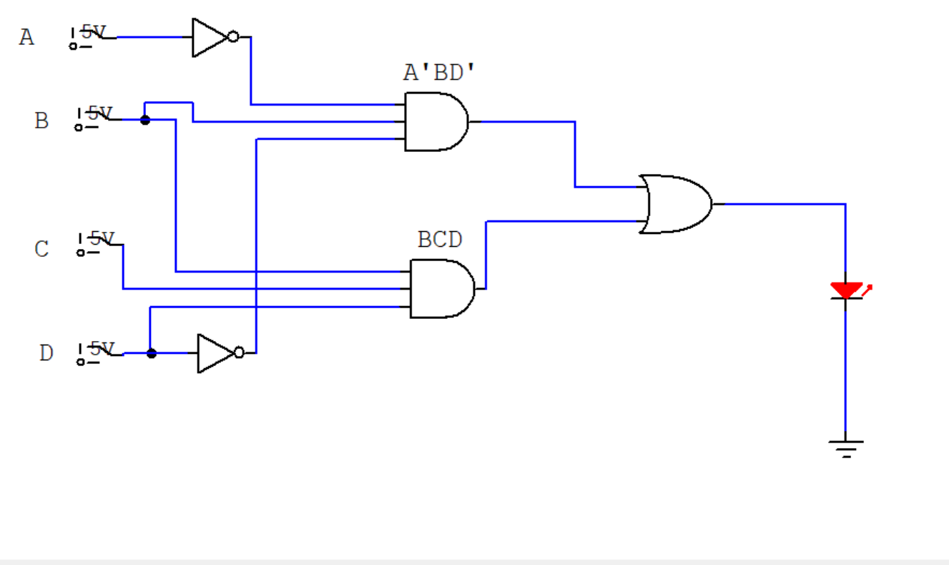

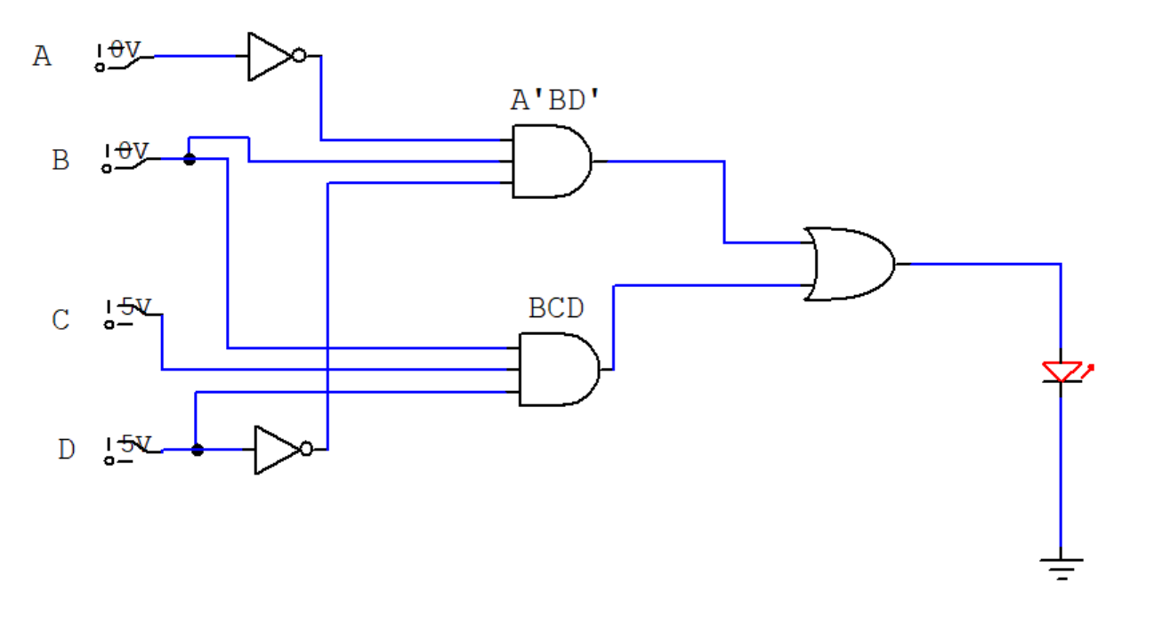

**Universal Gates**

**What are Universal Gates?**

**Universal gates** are logic gates that can be **used to build any other logic gate** like AND, OR, NOT, etc.

There are **2 universal gates**:

1. **NAND**
2. **NOR**

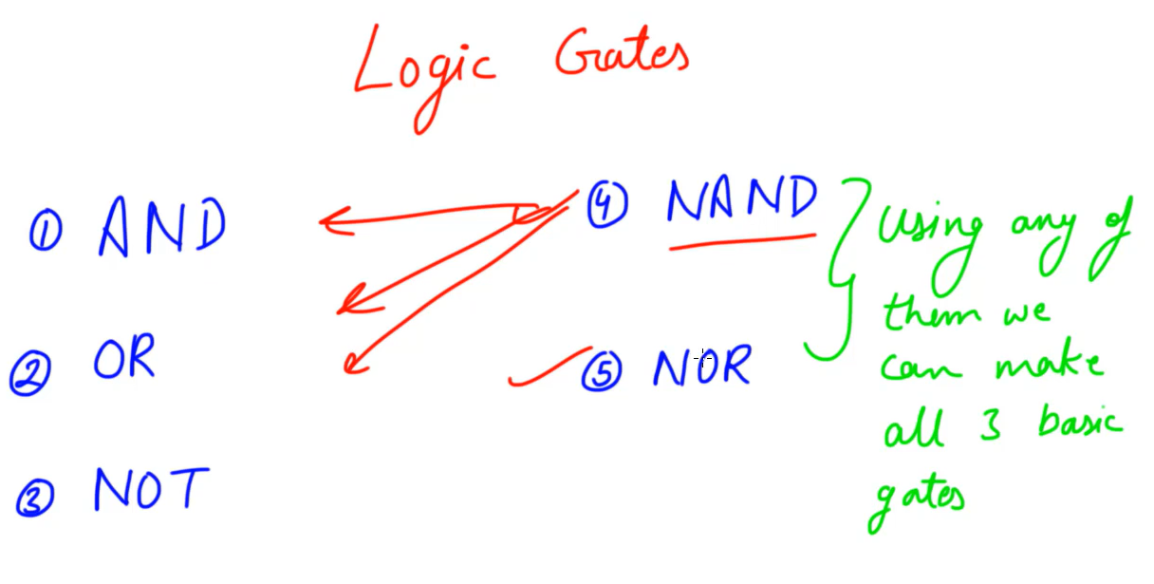

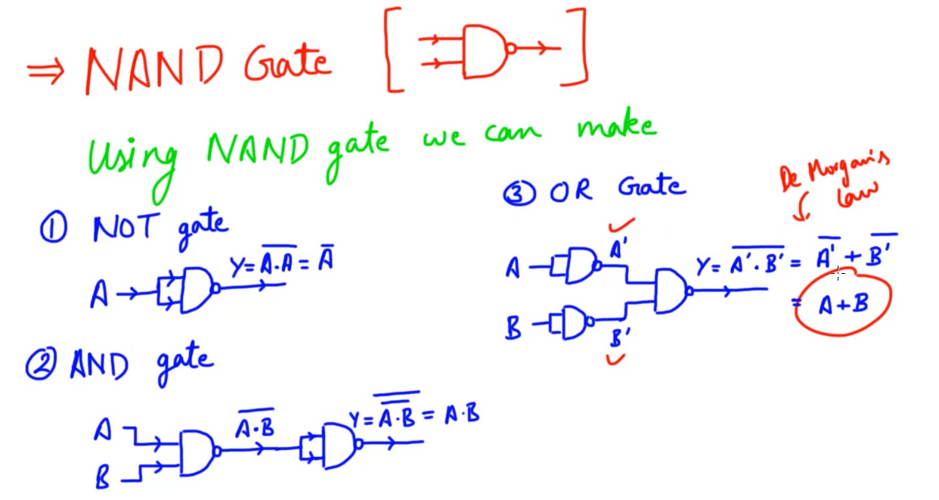

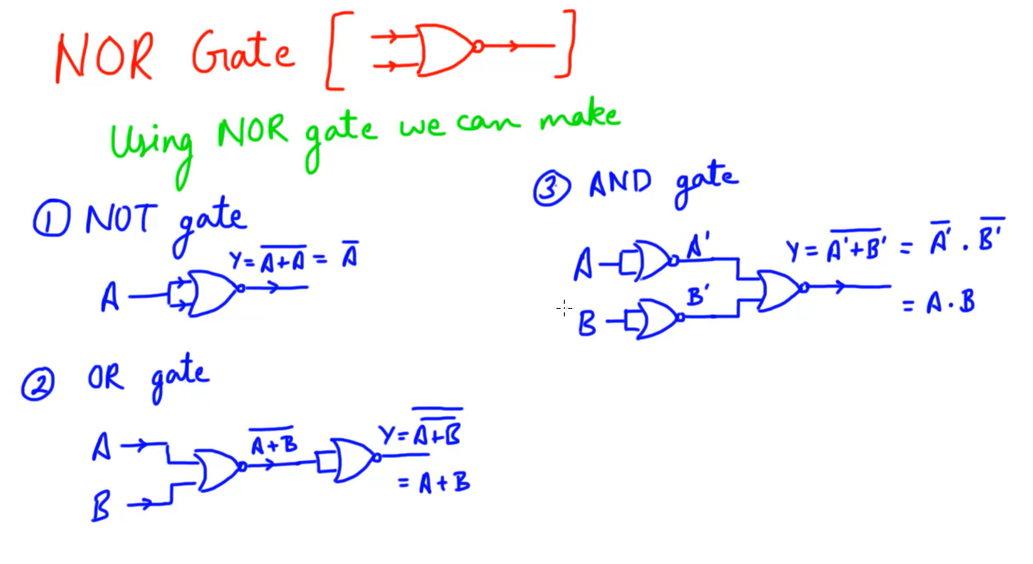

**LAB TASKS**

**TASK-01**

**Min term Expressions (SOP):**

1. F (A, B, C, D) = Σ (1, 3, 7, 9, 11, 14)
2. F (A, B, C) = Σ (0, 2, 5, 6)
3. F (A, B, C) = Σ (1, 3, 4, 7)
4. F (A, B, C, D) = Σ (0, 5, 6, 9, 11, 13)

**You have to do the followings:**

* Simplify using **K-Maps (first 2 for Standard SOP form and** last 2 for **Non-Standard SOP** form)**.**
* Derive the final Boolean expression.
* Implement using logic gates on **Circuit Maker**.

**Solution:**

**TASK-02**

Implement the NOT gate on Circuit Maker by using:

1. **NAND Gate ONLY** (Universal Gate)
2. **NOR Gate ONLY** (Universal Gate)

**Solution:**

**TASK-03**

Implement the following by using **NAND Gate ONLY** (Universal Gate).

1. Draw **2-Input AND gate** on white paper and also implement it on Circuit Maker.
2. Draw **2-Input NAND gate** on white paper and also implement it on Circuit Maker.
3. Draw **2-Input OR gate** on white paper and also implement it on Circuit Maker.

**Solution:**

**TASK-04**

Implement the following by using **NOR Gate ONLY** (Universal Gate).

1. Draw **2-Input AND gate** on white paper and also implement it on Circuit Maker.
2. Draw **2-Input NOR gate** on white paper and also implement it on Circuit Maker.
3. Draw **2-Input OR gate** on white paper and also implement it on Circuit Maker.

**Solution:**